**CDATA Excel Driver for HarperDB**

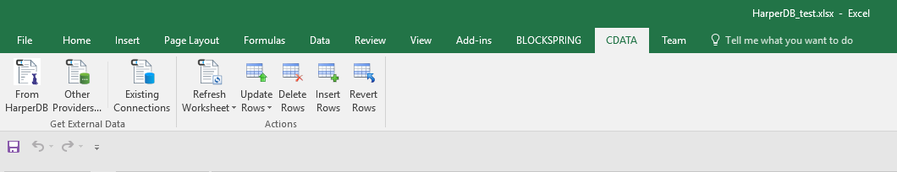1. After Installed the driver you can see tab ad-on on top like this,

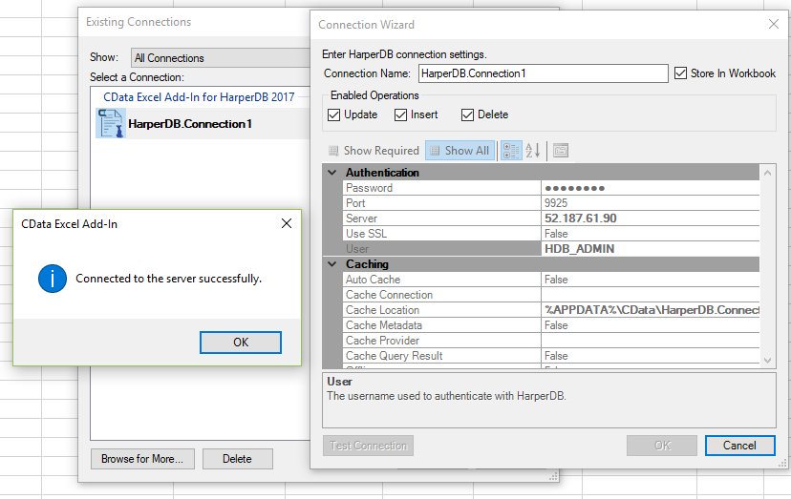2. Setting up database connection

**Tested 4 Bugs**

**1. Wildcards underscore '_'**

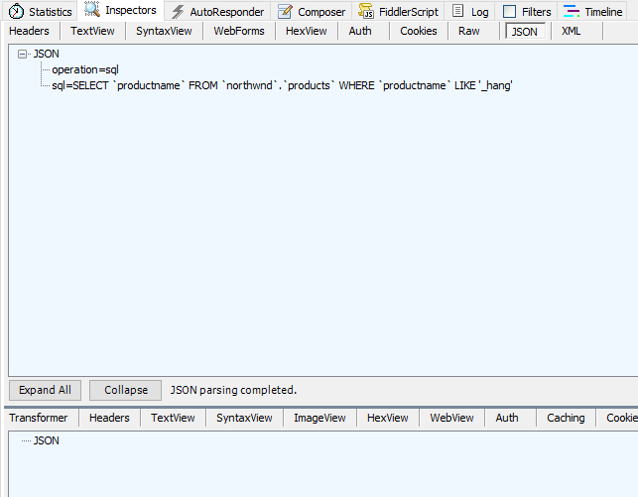 Sql : select productname from northwnd.products where productname like '_hang'  
 Expect result : Chang  
 Actual result : null

In Fiddler

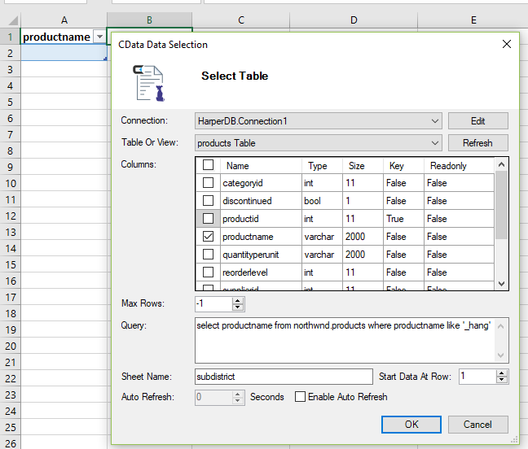

In Excel

In MS sql server

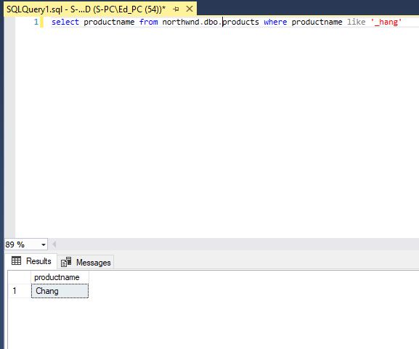

**2. Compare constants <**

Sql : select count(productid) from northwnd.products where unitprice<100  
Expect result : 75  
Actual result : 77

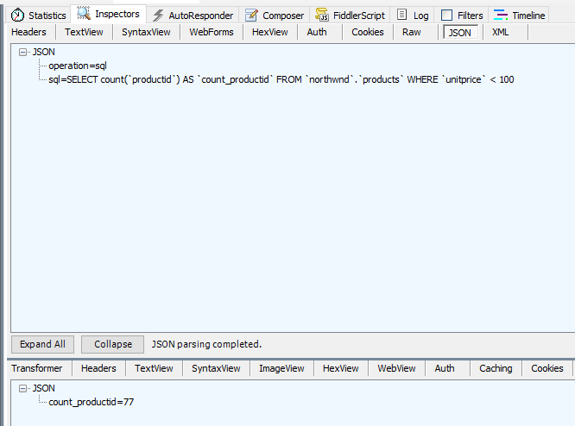

In Fiddler

In Excel

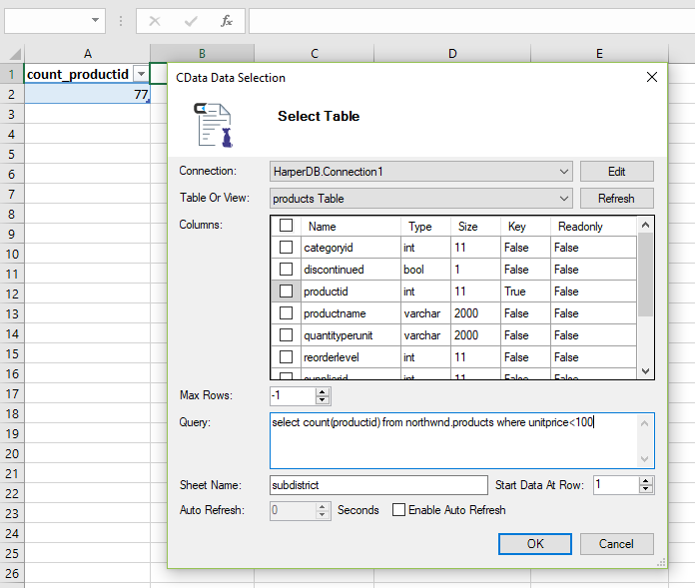

In MS sql server

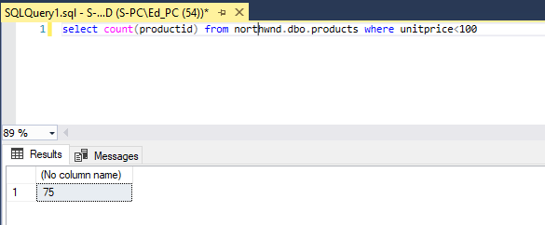

**3. Compare constants <=**

Sql : select count(productid) from northwnd.products where unitprice<=20  
Expect result : 40  
Actual result : 77

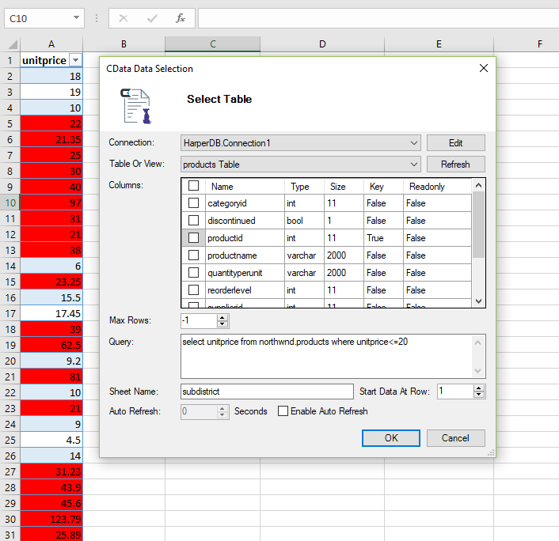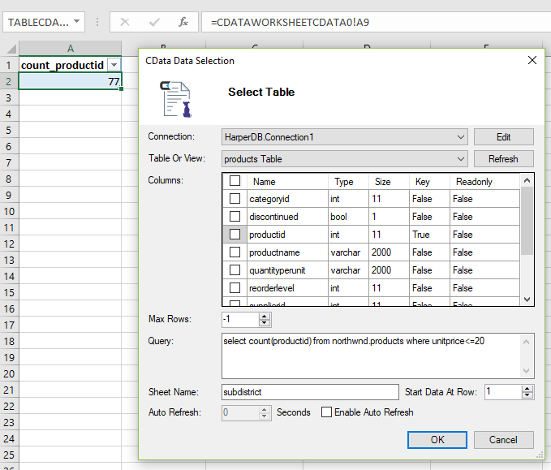

In Excel

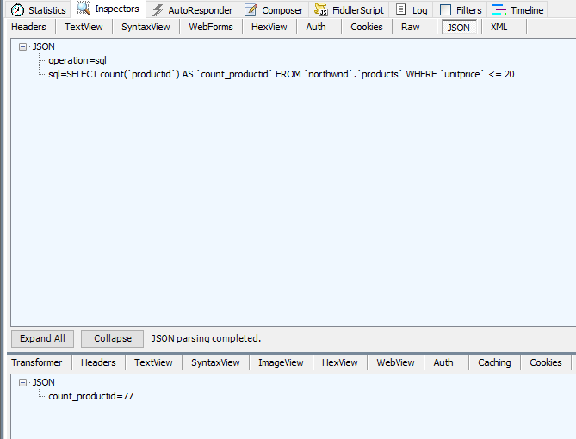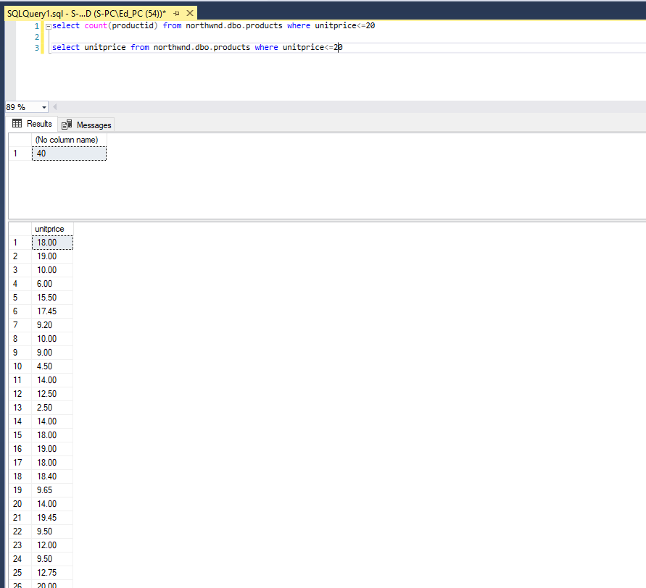

In MS sql server

In Fiddler

**4. Compare constants >=**

Sql : select count(productid) from northwnd.products where unitprice>=50  
Expect result : 7  
Actual result : 11

In Excel

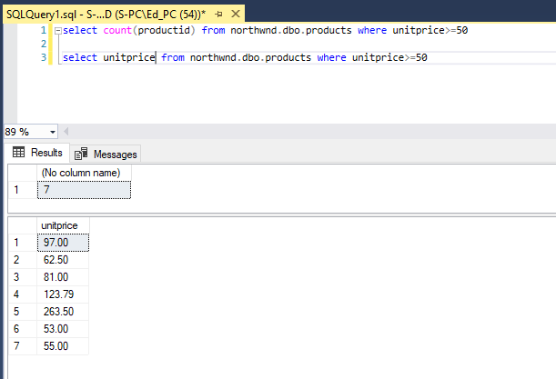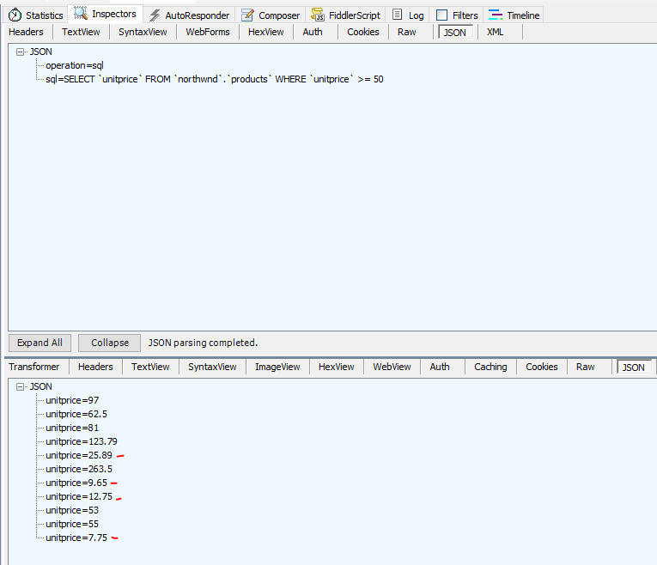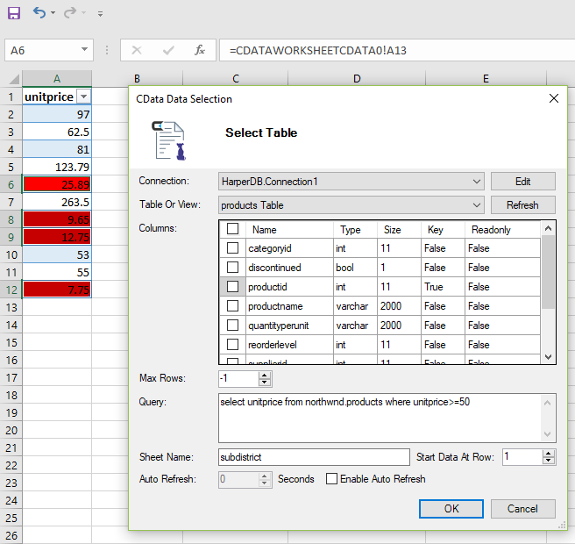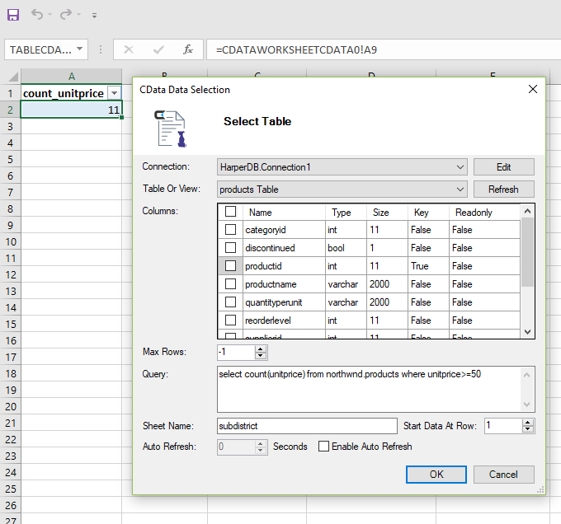

In MS sql server

In Fiddler